PROGRAM CODE
#include<stdio.h>
#include<stdlib.h>
#include<math.h>
int range, req, requests[50], head;
void fcfs ();
void scan ();
void cscan ();
void sort (int *arr, int size, int mode);
void seektimeFinder (int *arr, int max);
int main ()
{
printf ("\nENTER THE MAX RANGE OF THE DISK = ");
scanf ("%d", &range);
printf ("\nENTER THE NUMBER OF REQUESTS = ");
scanf ("%d", &req);
printf ("\nENTER THE DISK POSITIONS TO BE READ\n");
for (int i = 1; i <= req; i++)
{
scanf ("%d", &requests[i]);
}
printf ("\nENTER THE INITIAL HEAD POSITION = ");
scanf ("%d", &head);
int choice = 0;
while (choice != 4)
{
printf ("\n1.FCFS\n2.SCAN\n3.C-SCAN\n4.EXIT\nENTER A CHOICE >>> ");
scanf ("%d", &choice);
switch (choice)
{
case 1:fcfs ();
break;
case 2:scan ();
break;
case 3:cscan ();
break;
case 4:exit(0);
break;
default:printf ("\nINVALID");
}
}
}
void seektimeFinder (int *arr, int max)
{
int seek = 0, diff = 0;
for (int i = 0; i < max - 1; i++)
{
diff = abs (arr[i + 1] - arr[i]);
seek += diff;
printf ("\nDISC HEAD MOVES FROM %d TO %d WITH SEEK TIME %d", arr[i],
arr[i + 1], diff);
}
printf ("\n\nTOTAL SEEK TIME = %d", seek);
}
void fcfs ()
{
requests[0] = head;
seektimeFinder (requests, req + 1);
}
void scan ()
{
int q1[20], q2[20], k1 = 0, k2 = 0, queue[50], t1 = 0;
for (int i = 1; i <= req; i++)
{
if (requests[i] > head)
{
q2[k2] = requests[i];
k2++;
}
else
{
q1[k1] = requests[i];
k1++;
}
}
sort (q2, k2, 1);
sort (q1, k1, 2);
t1 = 1;
for (int i = 0; i < k2; i++)
{
queue[t1] = q2[i];
t1++;
}
queue[0] = head;
queue[t1] = range;
t1++;
for (int i = 0; i < k1; i++) //then reverse
{
queue[t1] = q1[i];
t1++;
}
seektimeFinder (queue, t1);
}
void cscan ()
{
int q1[20], q2[20], k1 = 0, k2 = 0, queue[50], t1 = 0;
for (int i = 1; i <= req; i++)
{
if (requests[i] > head)
{
q2[k2] = requests[i];
k2++;
}
else
{
q1[k1] = requests[i];
k1++;
}
}
sort (q2, k2, 1);
sort (q1, k1, 1);
t1 = 1;
for (int i = 0; i < k2; i++)
{
queue[t1] = q2[i];
t1++;
}
queue[0] = head;
queue[t1] = range;
t1++;
queue[t1] = 0;
t1++;
for (int i = 0; i < k1; i++)
{
queue[t1] = q1[i];
t1++;
}
seektimeFinder (queue, t1);
}
void sort (int *arr, int size, int mode)
{
int i, j, temp;
for (i = 0; i < size - 1; i++)
{
for (j = 0; j < size - i - 1; j++)
{
if (mode == 1 ? arr[j] > arr[j + 1] : arr[j] < arr[j + 1])
{
temp = arr[j];
arr[j] = arr[j + 1];
arr[j + 1] = temp;
}
}
}
}
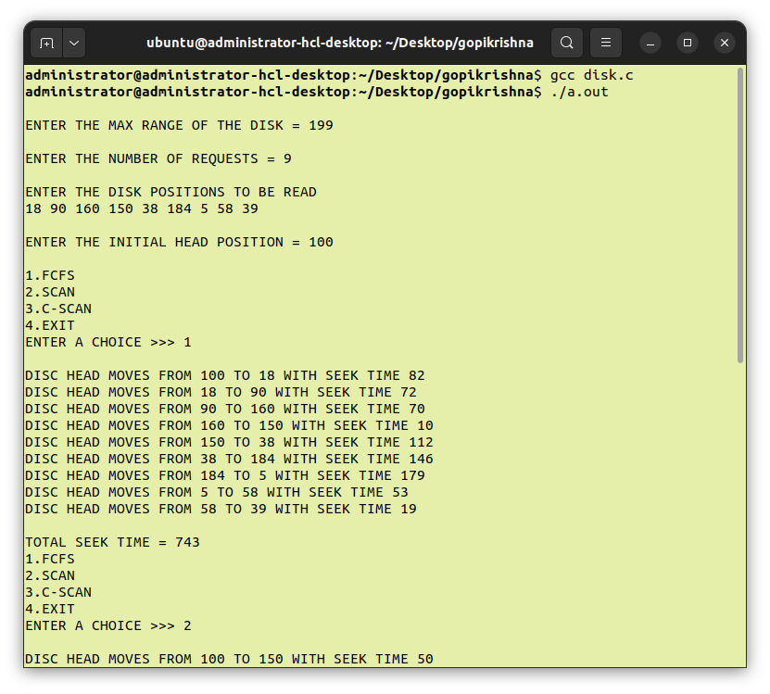
OUTPUT

